**Vegetable and Cheese Frittata**

**[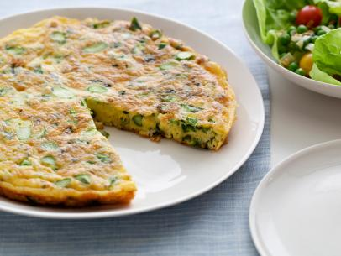](http://www.foodnetwork.com/recipes/aida-mollenkamp/asparagus-and-jack-cheese-frittata-recipe.print.html#lightbox-recipe-image) Herbs Cheese Options Vegetable Options**

Total Time: Parsley Mozzarella Bell Pepper

20 min Basil Cheddar Onions Mushrooms

Prep: Cilantro Mexican Blend Broccoli Spinach

10 min Italian Blend Tomatoes

Cook: Zucchini

10 min Green onions

Yield:

4-8 servings

Level:

Easy

**Ingredients**

* 6 large eggs
* 1/2 cup shredded cheese (you select the type of cheese)
* 1 teaspoon kosher salt
* Freshly ground black pepper
* 1 tablespoon [vegetable oil](http://www.foodterms.com/encyclopedia/vegetable-oils/index.html)
* 1 tablespoon butter
* 1 ½ cups total of cooked vegetables (you select the type and amount of each vegetable)
* 1 - 3 tablespoons roughly chopped fresh herbs (you select and chop the herb leaves)
* Serving suggestion: serve with a basic green salad

**Directions**

Heat the broiler to high and arrange rack in upper third.

In a large bowl, [whisk](http://www.foodterms.com/encyclopedia/whisk/index.html) together [eggs](http://www.foodterms.com/encyclopedia/eggs/index.html), cheese, salt, and freshly ground black pepper until thoroughly combined.

In a large ovenproof 12 inch [frying pan](http://www.foodterms.com/encyclopedia/frying-pan/index.html), heat the oil and the [butter](http://www.foodterms.com/encyclopedia/butter/index.html) over medium-high heat. When it foams, add vegetables, season well with salt and freshly ground black pepper, and cook, stirring occasionally, until cooked through, about 5 minutes. Stir in the [herbs](http://www.foodterms.com/encyclopedia/cilantro/index.html). Reduce heat to low, pour in egg mixture, and cook until a 1-inch border of egg mixture is firm, about 3 - 5 minutes. (The center of the [frittata](http://www.foodterms.com/encyclopedia/frittata/index.html) will not be set at this point.) Place the pan in oven and [broil](http://www.foodterms.com/encyclopedia/broil/index.html) until some spots are browned and eggs are just set, about 2 -4 minutes. Cut into wedges and serve with a side salad. It can be served warm or at room temperature.

**Planning**

Name: Cleaning Job… Cooking Jobs…list at least two

Cook____________________: ___________________________________________

Asst. Cook________________: __________________________________________

Asst. Cook____________________: _______________________________________

Asst. Cook_____________________: ______________________________________

Time you will put food in oven_____________

Time your group will begin final clean-up____________

**Evaluation**

1. Which combination of extra ingredients did your group select?
2. How did you like the flavors you selected?
3. Which other combinations of foods do you think would taste good?
4. A frittata is a quick, easy dinner option that can easily use up little bits of leftover meat, vegetables, cheese, and herbs. What other dinner options fit this criterion? (quick, easy, uses up ingredients already in your refrigerator)